KARIOS CubeSat Mission Verification
A structured, model-based verification procedure demonstrating that the KARIOS CubeSat meets all mission requirements, from conceptual design to in-orbit commissioning (ECSS-E-ST-10, MBSE/SysML).
Model strategy: EM → EQM → PFM | Reviews: full ECSS set (MDR, PRR, PDR, CDR, QR, AR, FRR, CRR, ELR)

Purpose and scope of mission verification
This section presents a defines the verification process for the KARIOS CubeSat mission, spanning initial conceptual design to in-orbit commissioning. Its purpose is to demonstrate that the delivered KARIOS spacecraft achieves all mission objectives--validating the design and verifying that the integrated system satisfies its requirements before launch.
The process is built on the ECSS space-engineering life-cycle (ECSS-E-ST-10), environmental testing standards, and CubeSat design specifications for structural and dimensional compliance. It is tailored for a small-satellite programme with constrained budget and schedule, and is executed within a Model-Based Systems Engineering (MBSE) framework using SysML, per the INCOSE Space Systems Working Group approach.

KARIOS verification methods
The requirement loop is closed using one or more of the four verification methods summarized in Table 1. The Verification Control Document (VCD) assigns each approach and tracks it back to a mission or system requirement.

Table 1: KARIOS mission verification method
Method | Description | Primary use in KARIOS
Testing (T) | Physical measurement on representative or flight hardware. | Structure, thermal, EMC/EMI, functional performance, deployment.
Analysis (A) | Analytical or computational prediction where test is impractical. | Orbital mechanics & coverage (STK), structural stress, thermal model, link & power budgets.
Review of design (RoD) | Inspection of design documentation and heritage evidence. | Interface control, heritage / COTS component reuse justification.
Inspection (I) | Direct visual and dimensional examination. | Dimensional & mass-envelope compliance to the CubeSat Design Specification.
The pre-launch STK simulation of KARIOS orbital dynamics, sun-synchronicity, lighting, ground-station contacts, coverage, and life span serves as the analytical evidence for this approach as shown in Figure 1 along with the orbital parameters presented in Table 2.

Table 2: KARIOS orbital elemental parameters
Orbit regime | SSO, approximately 550 km altitude
Inclination | 97.7444°
RAAN | 108.1576°
Eccentricity | 0.0006955
Argument of Perigee | 79.2781°
Mean Anomaly | 280.9219°
Orbital Period | 96.75 minutes
Mean Motion | 14.88 revolutions/day

Figure 1: Schematic diagram of the KARIOS orbital mission analysis
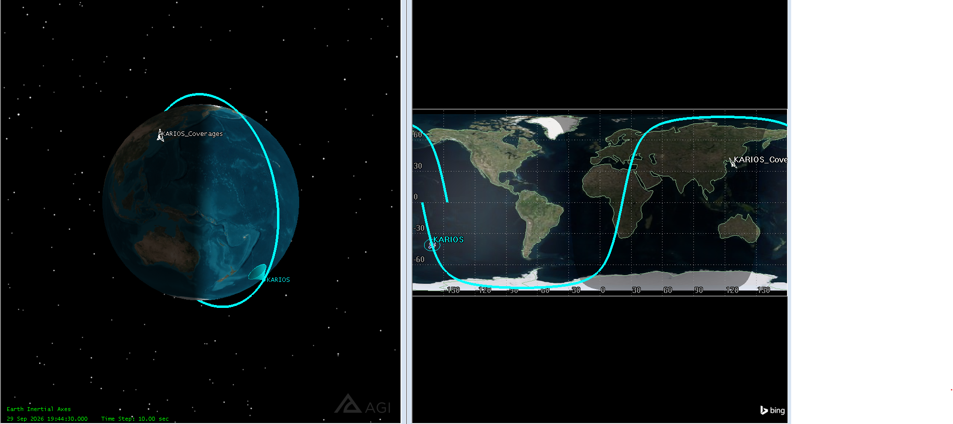

KARIOS Model philosophy
The KARIOS CubeSat employs a three-model technique presented in Table 3, modified from the ECSS Proto-Flight Model (PFM) approach, which was chosen because it achieves full certification confidence within the cost and time constraints of a CubeSat program by qualifying and flying representative hardware.
Table 3: KARIOS CubeSat model approaches
Model | Role | Test level
Engineering Model (EM) | Electrically & mechanically representative unit for early functional and interface verification. Flight-representative PCBs/panels; components need not be flight-grade. | Functional / development
Engineering Qualification Model (EQM) | Combined functional and qualification-level environmental testing (vibration, shock, thermal-vacuum at qualification margins) validating the design envelope. | Qualification
Proto-Flight Model (PFM) | The flight article, acceptance-tested at proto-flight levels (qualification amplitude, acceptance duration). Delivered for integration, launch campaign, and flight. | Proto-flight / acceptance

KARIOS life-cycle phases and design reviews
The mission verification programme is based on the ECSS-E-ST-10 life cycle as summarized in Table 4. Each phase is finished with a formal review gate that resolves the gathered verification evidence.
Table 3: KARIOS CubeSat life-cycle and design review processes
Phase | Definition | Review gate(s)
0 / A | Mission analysis, needs identification & feasibility | MDR, PRR
B | Preliminary definition — verification planning baselined | PDR
C | Detailed definition — methods allocated & executed | CDR
D | Qualification & production — model + environmental campaign | QR, AR
E | Operations — launch, LEOP, in-orbit demonstration & commissioning | FRR, CRR
F | Disposal — end-of-life & re-entry | ELR

KARIOS verification process
The flow is analyzed top-to-bottom to the ECSS stages and gate reviews as show in Figure 2. Requirements drive verification planning; planning allocates the four techniques; methods are carried out across the model and environmental test campaigns; results are stored in the VCD and closed at each review gate. Non-conformances (NCR/RID) provide input to the design for re-verification.
Mission & System Requirements [Phase 0 / A / B]
Captured in the SysML MBSE model → Requirements Verification Matrix (RVM).
▼
Verification Planning [Phase B → PDR]
Verification Plan authored; each requirement allocated a method, level, and model. Baseline of the Verification Control Document (VCD).
▼
Verification Methods — allocation & execution [Phase C / D]
Four methods allocated per requirement and executed:
Test (T) Analysis (A) Review (RoD) Inspection (I)
▼
Model Campaign [Phase C / D]
Verification distributed across the three-model strategy:
EM → EQM → PFM
▼
Environmental Test Campaign [Phase D → QR / AR]
Functional/DITL · Sine & random vibration · Mechanical shock · Thermal-vacuum & balance · EMC/EMI · Mass properties · Deployment test · Bake-out/outgassing.
▼
Verification Close-out [QR · AR]
Results dispositioned in the VCD; Verification Control Board closes each requirement with objective evidence. Every RVM item marked verified.
▼
Flight Readiness → Launch → LEOP [Phase D → E · FRR]
Pre-ship review, launch campaign, separation, and Launch & Early-Orbit Phase acquisition.
▼
In-Orbit Demonstration & Commissioning [Phase E · CRR]
On-orbit performance confirmed against requirements (IOD); mission validation and hand-over to routine operations.

Figure 2: Schematic block diagram of the KARIOS mission verification process
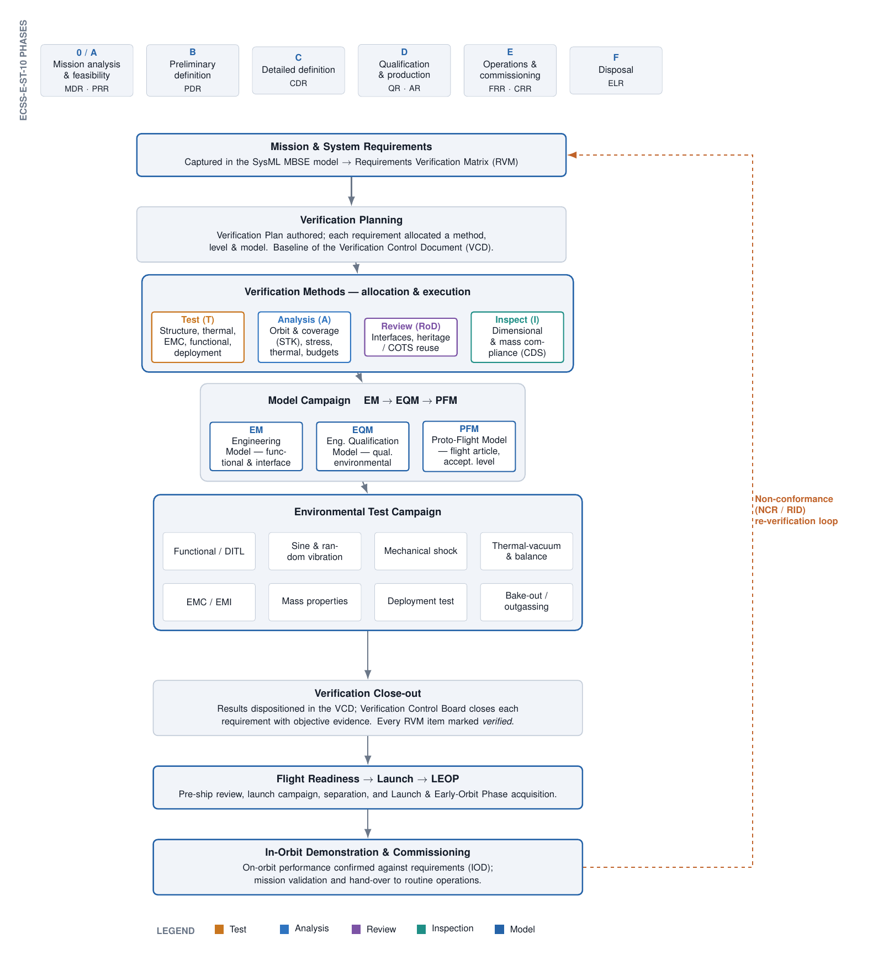

KARIOS CubeSat Model-Based Systems Engineering (MBSE) Process
An MBSE approach for the KAIST Intelligence & Reconnaissance Orbital Satellite (KARIOS), instantiated from the INCOSE Space Systems Working Group (SSWG) CubeSat Reference Model (CRM) and adapted from the RANDEV CubeSat programme.

Purpose and Rationale
Small satellites such as KARIOS are challenging to design due to the fact they lack sufficient resources, tightly coupled subsystems, and must operate in a dynamic space environment. Model-Based Systems Engineering (MBSE) addresses this by establishing a single, authoritative system model that combines requirements, architecture, behavior, and analysis into a single unified source of truth.
According to the INCOSE MBSE Initiative (Systems Engineering Vision 2020), the KARIOS system model is initiated at the beginning of a project and evolves throughout development and operations, offering a consistent foundation for requirements, design, analysis, verification, and validation. The technique is based on the INCOSE SSWG CubeSat Reference Model, which is related with the FireSat and Radio Aurora Explorer (RAX) reference models (Kaslow et al.) and is customized to KARIOS based on the RANDEV CubeSat MBSE description.

CubeSat Domain and Enterprise
Following the CRM, the KARIOS model is framed within the CubeSat Domain, which includes the Mission Enterprise, its stakeholders, the External Environment, and External Constraints.
Domain element | KARIOS instantiation
Mission Enterprise | Development, deployment, and operation of the KARIOS SIGINT + cybersecurity CubeSat mission by KAIST ASCL.
Stakeholders & Concerns | KAIST ASCL; IITP (funding, AI-satellite-vulnerability project); spectrum & regulatory agencies; launch/deployer provider; Cal Poly CubeSat Design Specification; INCOSE / OMG (SysML).
External Environment | Space environment (radiation, thermal, vacuum, debris) and Earth environment (ground stations, atmosphere).
External Constraints | Licenses & regulations: radio-frequency spectrum authorization and orbital-debris / disposal guidelines.

The Space Segment (KARIOS spacecraft), the Ground Segment (UHF and LoRaWAN ground-station services), along with Transportation / Launching / Deployment operations acquired from an external supplier are all modelled at the same level.

Stakeholders, Concerns, Viewpoints and Views
According to ISO/IEC/IEEE 42010, this method organizes stakeholder concerns into viewpoints and generates views that frame specific problems. For KARIOS, this means:
- Analyze mission requirements to identify enterprise-level use cases.
- Define the relationship between requirements and those use cases.
- Develop and capture use-case descriptions and scenarios in the model.
- Establish architecture viewpoints and render architecture views (structure, behaviour) that address regulatory, operational, and design concerns.
From a regulatory standpoint (spectrum authorization, orbital-debris compliance), licenses, timelines, and procedures must be properly understood and traceable within the model.

The KARIOS SysML System Model
The MBSE model is generated using SysML (MagicDraw / Cameo Systems Modeler) and organized around four SysML pillars as shown in Figure 3. Each pillar is developed with KARIOS content:
- Requirements. Mission requirements are categorized into system and subsystem requirements. Satisfy relationships link requirements to the value characteristics they constrain, while Verify relationships connect them to the verification activities that close them, resulting in the Requirements Verification Matrix (RVM). (see req [package] Requirements [ KARIOS Requirement Traceability] figure)
- Structure. The architecture is captured in Block Definition and Internal Block Diagrams (BDD / IBD), which include the Space, Ground, and Launch segments; the bus subsystems OBC, EPS, ADCS, Communications (UHF + LoRaWAN), Structure, and Thermal Control; and the payloads, SIGINT primary payload and cybersecurity secondary payload, as well as their interfaces. (see bdd [package] Structure [ KARIOS System Decomposition figure]
- Behavior. Operation models are represented by use cases, activity diagrams, and state machines. A top-level 'Collect & Distribute Mission Data' activity is divided into three components: mission tasking, data collection, and downlink. A CubeSat state machine records Orbit, Solar (sunlight/eclipse), Payload (collecting/idle), and Download (transmitting/not) states, which may overlap operationally. (see uc [package] Behavior [ KARIOS Mission Use Cases] and act [activity] CollectAndDistributeMissionData figure)
- Parametrics. Parametric diagrams represent engineering budgets as constraint blocks, with power (generation vs. load and battery status), data (buffer fill vs. downlink volume), the communications link budget, and coverage / contact time evaluated at each simulation time step.

Figure 3: KARIOS Model based System engineering System process
